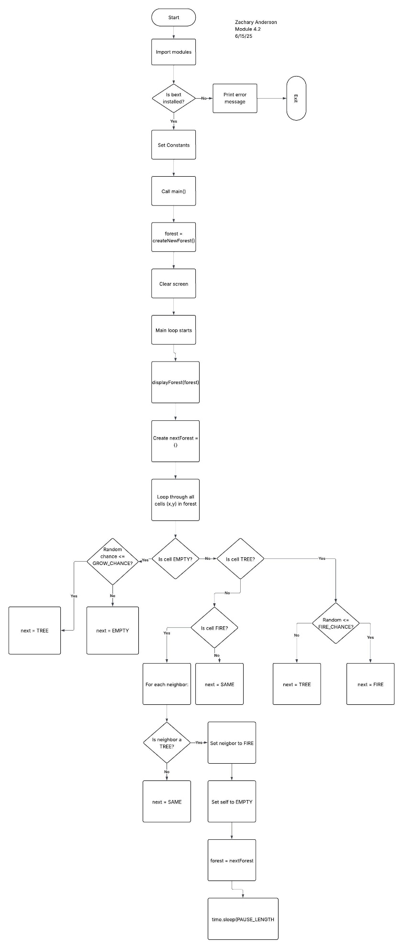

Yes

Was CTRL-C pressed?

No

Repeat Loop